2303A51254

N.VAISHNAVI

Batch – 18

Task Description #1:

Security Context)

Assignment 8.1

(Password Strength Validator – Apply AI in

• Task: Apply AI to generate at least 3 assert test cases for is_strong_password(password) and implement the validator function.
• Requirements:

o Password must have at least 8 characters.

o Must include uppercase, lowercase, digit, and special character. o Must not contain spaces. Example Assert Test Cases: assert is_strong_password("Abcd@123") == True
assert is_strong_password("abcd123") == False assert is_strong_password("ABCD@1234") == True Expected Output #1:
• Password validation logic passing all AI-generated test cases. Prompt :
#Create a Python function is_strong_password(password) that validates password strength.
#The password must: #Have at least 8 characters
#Contain at least one uppercase letter #Contain at least one lowercase letter

#Contain at least one digit
#Contain at least one special character #Must not contain spaces
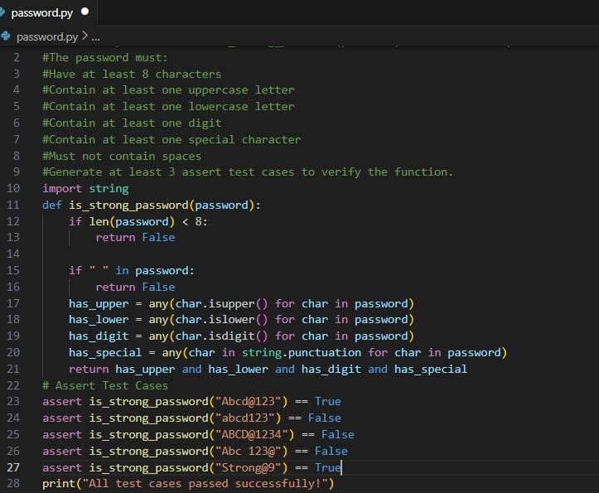
#Generate at least 3 assert test cases to verify the function.

Output

Analysis
1.The password validator checks multiple security conditions.

2. The AI-generated assert test cases helped verify both valid and invalid scenarios.

3. no assertion errors occurred, the function works correctly.

Task Description #2: (Number Classification with Loops – Apply

AI for Edge Case Handling)

• Task: Use AI to generate at least 3 assert test cases for a classify_number(n) function. Implement using loops.
• Requirements:

o Classify numbers as Positive, Negative, or Zero. o Handle invalid inputs like strings and None. o Include boundary conditions (-1, 0, 1). Example Assert Test Cases:
assert classify_number(10) == "Positive" assert classify_number(-5) == "Negative" assert classify_number(0) == "Zero" Expected Output #2:
• Classification logic passing all assert tests. Prompt :
#Number Classification with Loops classify_number(n) function. Implement using loops.

#Classify numbers as Positive, Negative, or Zero.

# Handle invalid inputs like strings and None.

# Include boundary conditions (-1, 0, 1).

# Test cases from user input
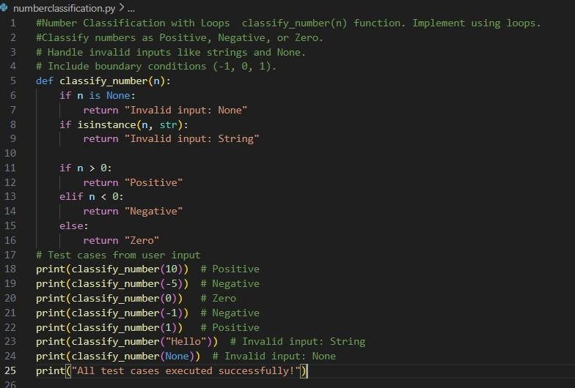
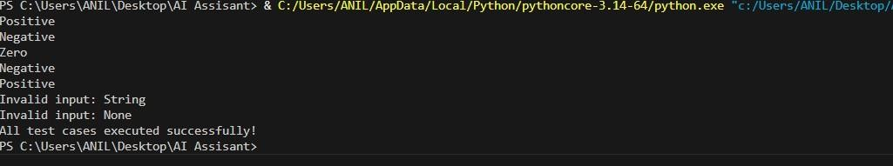

Code:

Output:

Analysis:
1. The function classifies numbers into Positive, Negative, or Zero.
2.Invalid inputs like strings and None return "Invalid Input".
3. AI-generated assert cases helped verify normal cases, edge cases, and invalid inputs.

Task Description #3: (Anagram Checker – Apply AI for String Analysis)
• Task: Use AI to generate at least 3 assert test cases for is_anagram(str1, str2) and implement the function.
• Requirements:

o Ignore case, spaces, and punctuation. o Handle edge cases (empty strings, identical words). Example Assert Test Cases:
assert is_anagram("listen", "silent") == True assert is_anagram("hello", "world") == False assert is_anagram("Dormitory", "Dirty Room") == True Expected Output #3:
• Function correctly identifying anagrams and passing all AI-generated tests.
Prompt :

#Anagram Checker least 3 assert test cases foris_anagram(str1, str2) and implement the function.

#Ignore case, spaces, and punctuation.

# Handle edge cases (empty strings, identical words).

# Test cases from user input
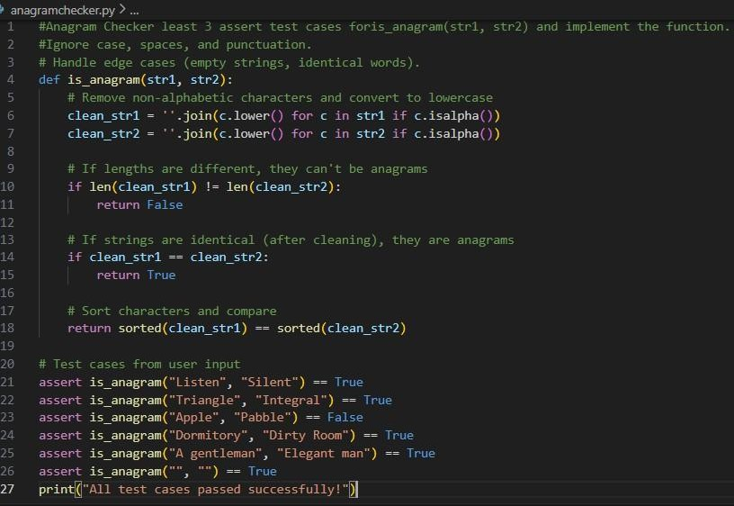

Output:

Analysis:

1. The function checks if two strings are anagrams.

2. AI-generated assert test cases verified both valid and invalid scenarios.

3. Since no assertion errors occurred, the function works correctly.

Task Description #4:
(Inventory Class – Apply AI to Simulate Real-

World Inventory System)

• Task: Ask AI to generate at least 3 assert-based tests for an Inventory class with stock management.
• Methods:

o add_item(name, quantity) o remove_item(name, quantity) o get_stock(name) Example Assert Test Cases: inv = Inventory() inv.add_item("Pen", 10) assert inv.get_stock("Pen") == 10 inv.remove_item("Pen", 5) assert inv.get_stock("Pen") == 5 inv.add_item("Book", 3) assert inv.get_stock("Book") == 3 Expected Output #4:
• Fully functional class passing all assertions.

Prompt :

#The class must include:

#add_item(name, quantity)

#remove_item(name, quantity)

#get_stock(name) #Requirements: #Prevent removing more stock than available.

#Handle items that do not exist.

#Generate at least 3 assert-based test cases to validate functionality.

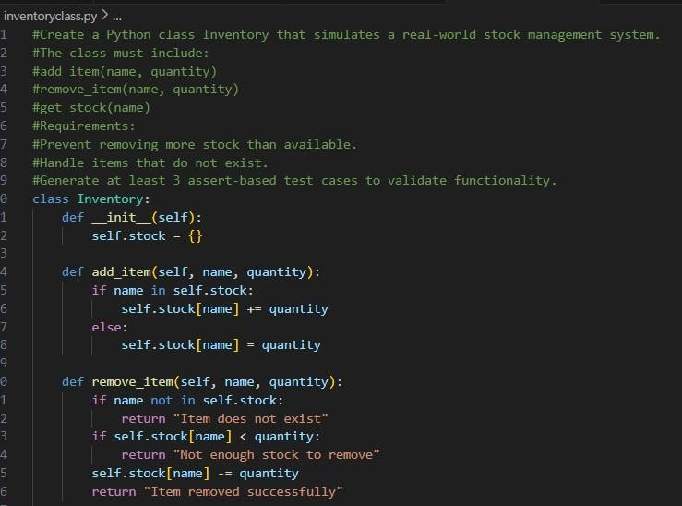
Code :
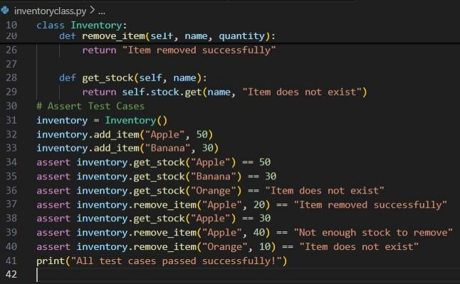

Output

Analysis:

1. AI-generated assert tests validated real-world scenarios like:

• Adding stock

• Removing stock

• Checking non-existent items

• Preventing over-removal

2. Since no assertion errors occurred, the system works correctly.

Task Description #5:
(Date Validation & Formatting – Apply AI for

Data Validation)

• Task: Use AI to generate at least 3 assert test cases for validate_and_format_date(date_str) to check and convert dates.
• Requirements:

o Validate "MM/DD/YYYY" format. o Handle invalid dates.
o Convert valid dates to "YYYY-MM-DD". Example Assert Test Cases:
assert validate_and_format_date("10/15/2023") == "2023-10-15" assert validate_and_format_date("02/30/2023") == "Invalid Date" assert validate_and_format_date("01/01/2024") == "2024-01-01" Expected Output #5:
• Function passes all AI-generated assertions and handles edge cases.
Prompt :
#Validates the date in "MM/DD/YYYY" format #Handles invalid dates (e.g., February 30) #Converts valid dates into "YYYY-MM-DD" format
#Generates at least 3 assert test cases including edge cases # Assert Test Cases from user input

Code :
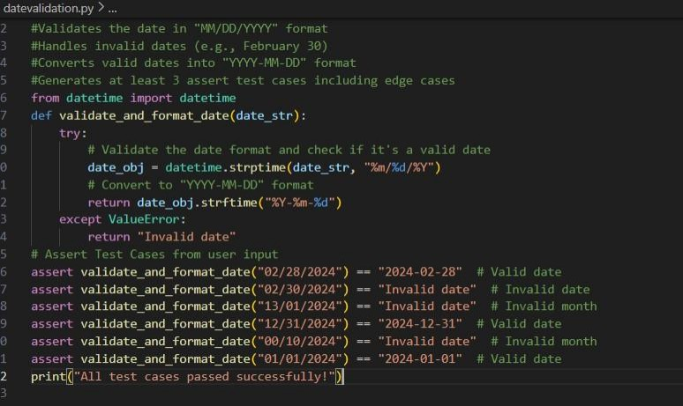

Output :

Analysis:
1. The function validates dates using Python’s datetime module.
2. AI-generated assert cases helped verify correct and incorrect inputs. 3. Since no assertion errors occurred, the function works correctly.

